**DDL COMMANDS**

**CREATE TABLE Author(Author_id number(5),Name varchar(20),Email varchar(50),Phone number(10),status varchar(10));**

**DESC Author;**

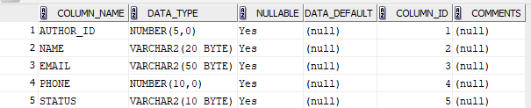

table AUTHOR created.

Desc Author

Name Null Type

--------- ---- ------------

AUTHOR_ID NUMBER(5)

NAME VARCHAR2(20)

EMAIL VARCHAR2(50)

PHONE NUMBER(10)

STATUS VARCHAR2(10)

**CREATE TABLE Book_Author(Author_id number(5), Book_id number(5));**

**DESC Book_Author;**



table BOOK_AUTHOR created.

DESC Book_Author

Name Null Type

--------- ---- ---------

AUTHOR_ID NUMBER(5)

BOOK_ID NUMBER(5)

**CREATE TABLE Publisher(Publisher_id number(5), Name varchar(20), Address varchar(50));**

**DESC Publisher;**

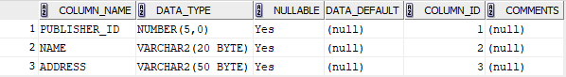

table PUBLISHER created.

DESC Publisher

Name Null Type

------------ ---- ------------

PUBLISHER_ID NUMBER(5)

NAME VARCHAR2(20)

ADDRESS VARCHAR2(50)

**CREATE TABLE Member(Member_id number(5), Name varchar(20), Branch_code number (10), Roll_number number(10),Phonenumber number(10), Email varchar(50), Date_of_join number(10),status varchar(10));**

**DESC Member;**

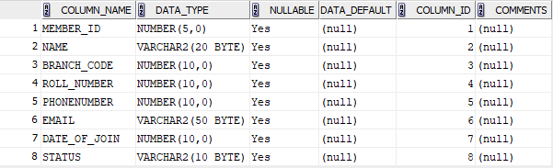

table MEMBER created.

DESC Member

Name Null Type

------------ ---- ------------

MEMBER_ID NUMBER(5)

NAME VARCHAR2(20)

BRANCH_CODE NUMBER(10)

ROLL_NUMBER NUMBER(10)

PHONENUMBER NUMBER(10)

EMAIL VARCHAR2(50)

DATE_OF_JOIN NUMBER(10)

STATUS VARCHAR2(10)

**CREATE TABLE Book_Issue(Issue_id number(5), Book_id number(20), Member_id number (10), Date_of_issue varchar(10),status varchar(10), Expected_date_of_return varchar(10));**

**DESC Book_Issue;**

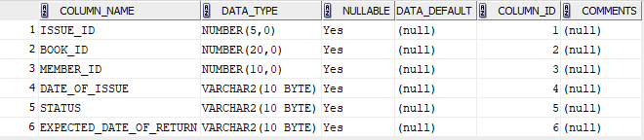

table BOOK_ISSUE created.

DESC Book_Issue

Name Null Type

----------------------- ---- ------------

ISSUE_ID NUMBER(5)

BOOK_ID NUMBER(20)

MEMBER_ID NUMBER(10)

DATE_OF_ISSUE VARCHAR2(10)

STATUS VARCHAR2(10)

EXPECTED_DATE_OF_RETURN VARCHAR2(10)

**CREATE TABLE Book_Return( Issue_id NUMBER(5), Actual_date_of_return VARCHAR(10), Late_Days VARCHAR(10), Late_Fees NUMBER(10));**

**DESC Book_Return;**

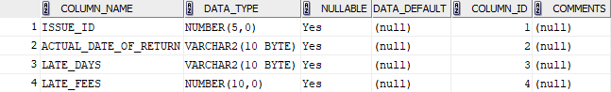

table BOOK_RETURN created.

DESC Book_Return

Name Null Type

--------------------- ---- ------------

ISSUE_ID NUMBER(5)

ACTUAL_DATE_OF_RETURN VARCHAR2(10)

LATE_DAYS VARCHAR2(10)

LATE_FEES NUMBER(10)

**CREATE TABLE Book(Book_id number(10) PRIMARY KEY, Title varchar(20), Language_id number(10), MRP number(10), Publisher_id number(10), Published_date number(10), Volume number(10), Status varchar(20));**

**DESC Book;**

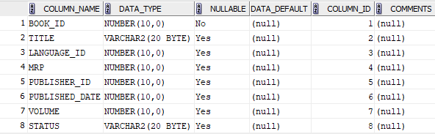

table BOOK created.

DESC Book

Name Null Type

-------------- -------- ------------

BOOK_ID NOT NULL NUMBER(10)

TITLE VARCHAR2(20)

LANGUAGE_ID NUMBER(10)

MRP NUMBER(10)

PUBLISHER_ID NUMBER(10)

PUBLISHED_DATE NUMBER(10)

VOLUME NUMBER(10)

**CREATE TABLE Language( Language_id number(10), Name varchar(20));**

**DESC Language;**

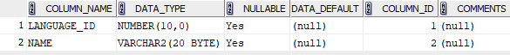

table LANGUAGE created.

DESC Language

Name Null Type

----------- ---- ------------

LANGUAGE_ID NUMBER(10)

NAME VARCHAR2(20)

**CREATE TABLE Late_FEE_Rule(FromDays number(10), ToDays number(10),Amount number(5), PRIMARY KEY(FromDays,ToDays,Amount));**

**DESC Late_FEE_Rule;**

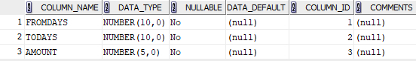

table LATE_FEE_RULE created.

DESC Late_FEE_Rule

Name Null Type

-------- -------- ----------

FROMDAYS NOT NULL NUMBER(10)

TODAYS NOT NULL NUMBER(10)

AMOUNT NOT NULL NUMBER(5)

**ALTER TABLE MEMBER MODIFY DATE_OF_JOIN VARCHAR(30);**

table MEMBER altered.

DESC MEMBER

Name Null Type

------------ -------- ------------

MEMBER_ID NOT NULL NUMBER(5)

NAME VARCHAR2(20)

BRANCH_CODE NUMBER(10)

ROLL_NUMBER NUMBER(10)

PHONENUMBER NUMBER(10)

EMAIL VARCHAR2(50)

DATE_OF_JOIN VARCHAR2(30)

STATUS VARCHAR2(10)

**TRUNCATE TABLE PUBLISHER;**

table PUBLISHER truncated.

**ALTER TABLE AUTHOR DROP COLUMN AUTHOR_ID CASCADE CONSTRAINTS;**

column AUTHOR_ID was dropped.

**ALTER TABLE LATE_FEE_RULE TABLE RENAME TO FINE;**

table LATE_FEE_RULE altered.